**Configure Relationship the**

|  |  |
| --- | --- |
| Team Id | LTVIP2025TMID29041 |
| Project Name | Calculating family expenses |
| college | Kandula Lakshumma Memorial College of Engineering for Women |
| course | Computer Science  Engineering |

**Configure Relationship the**

Logically connect two related tables so data can be linked, referenced, and accessed easily supporting better data structure, consistency, and reporting.

1. Go to All >> In the filter search for Relationships >> Open Relationships.
2. In that, open Daily Expenses Relationship.

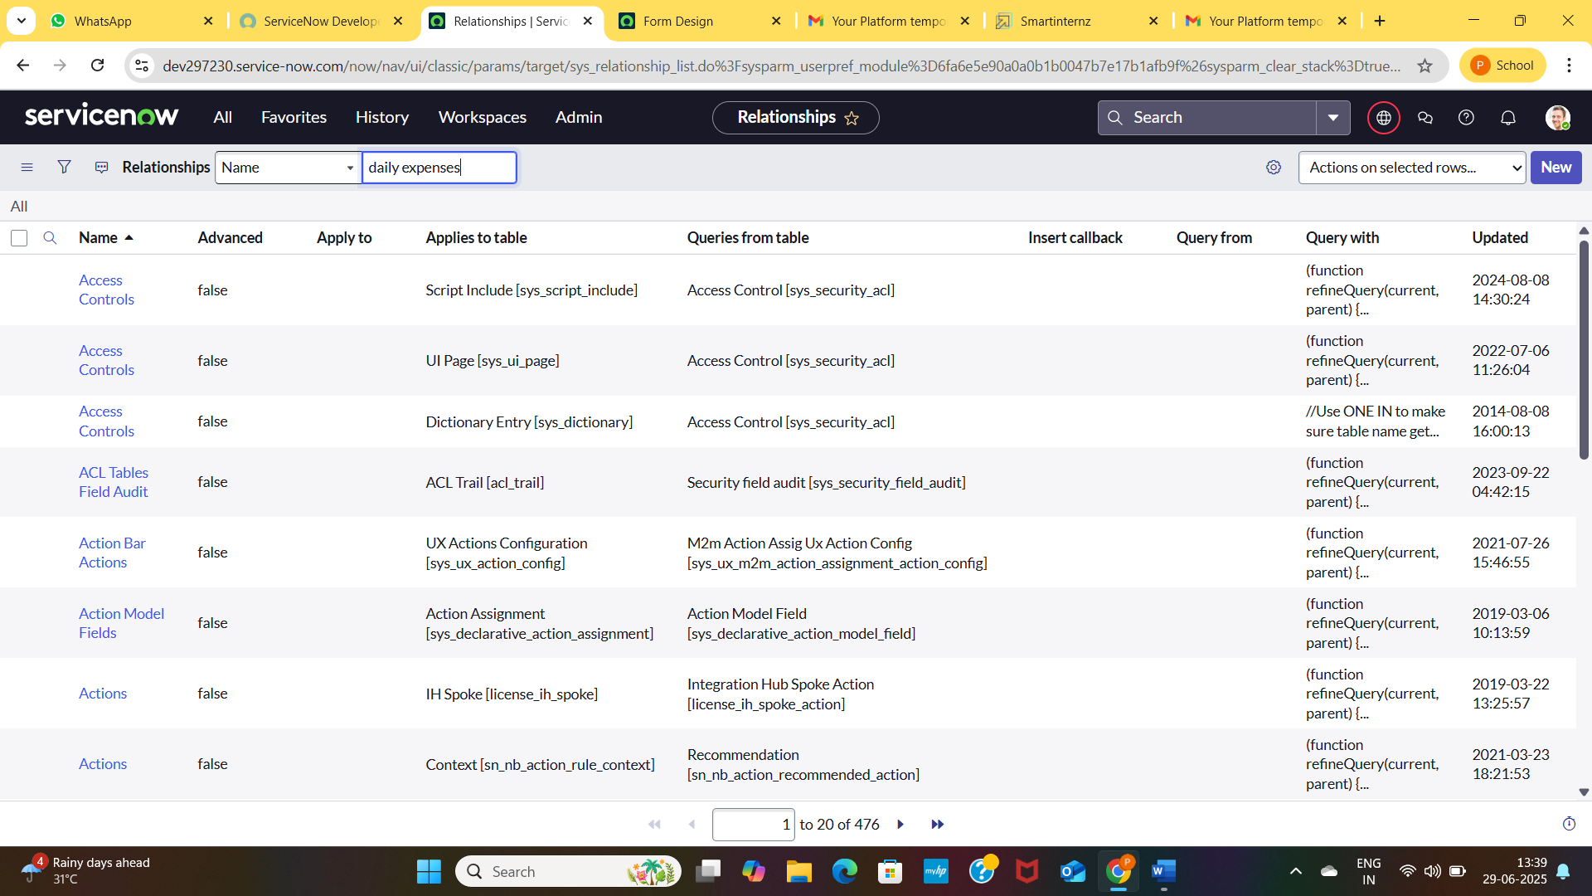

1. For Applies to table : Select Family Expenses.
2. In Query with : write the below Query.

function refineQuery(current, parent) {

// Add your code here, such as current.addQuery(field, value);

current.addQuery('u_date',parent.u_date);

current.query();

})(current, parent);

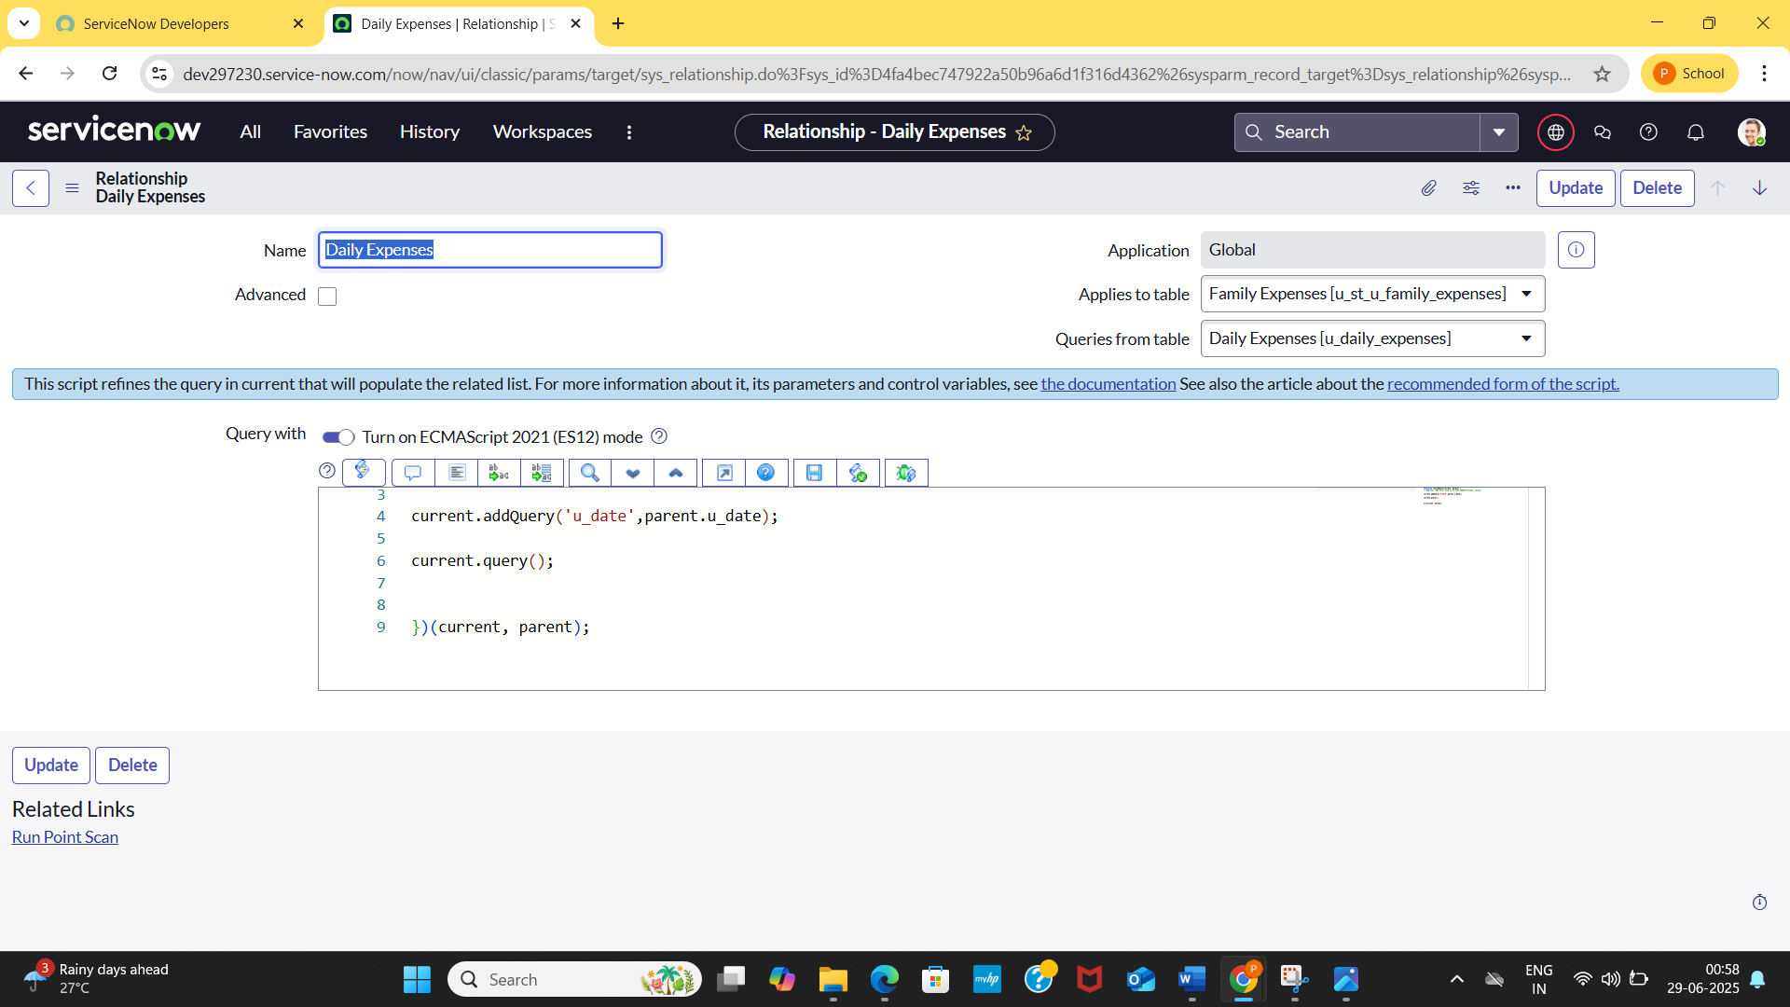

1. Cllick on Update